DERMANET – SKIN CANCER DETECTION
Project Report
Machine Learning
24AD2204
submitted by
Sriram Supreeth Divi (2410080010)
Vishal Vemula (2410080029)
Arnav Mishra (2410080008)
Shahid (2410080056)

Koneru Lakshmaiah Education Foundation, Aziz Nagar, Moinabad Road, Near TS Police Academy, Hyderabad, Telangana, India. Pin code: 500075

INTRODUCTION

1. Introduction To Project
Skin cancer is one of the most common cancers worldwide, and early, accurate diagnosis is critical for improving patient outcomes. However, visual assessment of dermascopic images can be challenging even for experienced clinicians, and real-world dermatology datasets often exhibit strong class imbalance. These dermascopic images have more benign lesions than malignant ones which may lead to tougher decision making and missing out on detecting cancer actually. DermaNet is a deep learning–based system designed to classify skin lesion images as malignant or benign using the HAM10000 dermascopic image dataset. The project leverages transfer learning with a pretrained ResNet50 backbone to learn robust visual features while reducing training time and data requirements. To better reflect clinical decision-making and simplify downstream use, the original seven lesion categories are consolidated into a binary label set, and targeted data augmentation is applied to mitigate malignant-class underrepresentation.

Literature Review:-
Deep learning has become a dominant approach for automated skin lesion analysis because dermascopic images contain complex visual patterns (asymmetry, border irregularity, color variegation, texture) that are difficult to encode with hand-crafted features. While CAD followed by engineered descriptors and classical classifiers methods established useful baselines, their performance and robustness often depended heavily on consistent imaging conditions and accurate segmentation, which is not always reliable in clinical settings. Convolutional Neural Networks (CNNs) demonstrated significant improvements by learning discriminative features directly from pixel data. A widely cited milestone is the work showing dermatologist-level performance for skin cancer classification using deep CNNs trained on large image collections. A consistent finding across the literature is that dermoscopy datasets are imbalanced, often with benign lesions far outnumbering malignant ones. This matters because naïve training can produce deceptively high accuracy while failing to detect malignancies (high false negatives), which is clinically costly. DermaNet follows a well-established, defensible research pattern for HAM10000: transfer learning with a proven CNN backbone (ResNet50), binary consolidation aligned with screening, and targeted augmentation to address imbalance.

PROBLEM STATEMENT:-
Skin cancer cases are increasing worldwide, and early detection significantly improves treatment outcomes. However, diagnosing skin lesions from dermoscopic images can be time-consuming and subjective, and real-world datasets are often imbalanced with far more benign than malignant cases. This project, DermaNet, aims to develop a deep learning–based binary classifier that labels skin lesion images as malignant or benign using the HAM10000 dataset, with strategies to address class imbalance and support consistent screening and clinical decision-making.
The goal is to develop a deep learning model for binary classification of skin lesions as malignant or benign using the HAM10000 dataset, addressing the significant class imbalance present in dermatological image data.
The approach used in this project is: Implemented a transfer learning approach using a pretrained ResNet50 architecture. The HAM10000 dataset was preprocessed to consolidate seven lesion types into two classes: malignant (melanoma, basal cell carcinoma, actinic keratoses) and benign (melanocytic nevi, benign keratosis, dermatofibroma, vascular lesions). To address the 3:1 class imbalance, data augmentation techniques including horizontal flipping and brightness adjustment were applied to the minority malignant class during training.

Tech Stack:-
The tech stack used for the project is:-
1) PyTorch
2) Pandas
3) SciPy
4) ResNet50 model
5) SciKit Learn
6) Matplotlib
Key Features:-
1) Binary Skin Lesion Classification (Malign or Benign) Using HAM10000 Dataset.
2) Transfer learning using a pretrained ResNet50 backbone.
3) Class imbalance handling (≈3:1) via targeted augmentation for malignant class (flip + brightness).
4) Preprocessing pipeline with consistent image resizing (300×225).
5) Stratified train/test split (80/20) to preserve class distribution.
6) Training setup: SGD optimizer (lr 0.001, momentum 0.5), cross-entropy loss, batch size 16.
7) Confusion Matrix Plotting using Seaborn Library.
8) Model evaluation using test accuracy and confusion matrix to assess both classes.
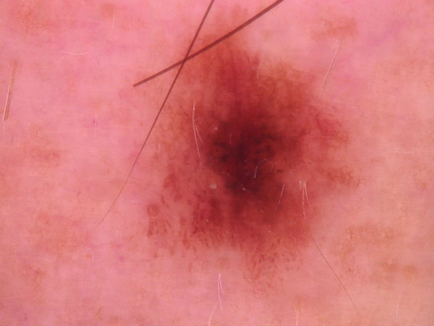
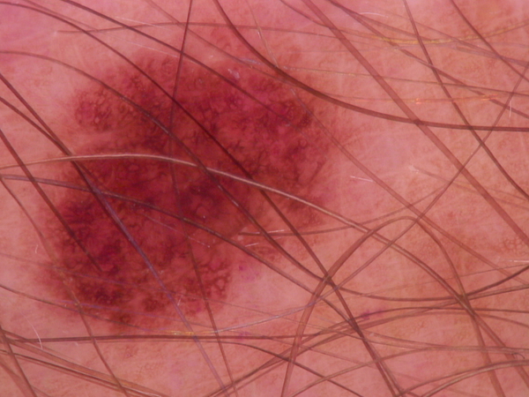
Methodology:-
Use the HAM10000 dermoscopic image dataset as the source of labeled skin lesion images.
Merge the original 7 diagnostic categories into 2 classes: Malignant and Benign.
Resize all images to a consistent input size of 300×225 and build a clean data pipeline for loading and batching images.
Apply a stratified 80/20 split to preserve class proportions in both sets.
Technical Implementation:-
- Data preprocessing pipeline with stratified train/test split (80/20).
- Image resizing to 300x225 pixels for consistent input dimensions.
- SGD optimizer with learning rate 0.001 and momentum 0.5
- Cross-entropy loss function.
- Batch size of 16 with 4 worker processes for data loading.
- Full fine-tuning of all ResNet50 layers rather than just the classifier head.
Results and Evaluation:-
The trained DermaNet model achieved 89.4% accuracy on the held-out test set after 10 epochs.
Training accuracy reached 98.5%, while test accuracy stabilized around 87–89% in later epochs.
A confusion matrix was used to verify predictions for both malignant and benign classes and to inspect the types of errors (false positives/false negatives).
The model performs reasonably well on both classes.
There are 10,015 dermatoscopic images with 1,954 malignant images and 8,061 benign images.

Conclusion:-
DermaNet demonstrates that transfer learning with a pretrained ResNet50 can effectively classify HAM10000 skin lesion images into malignant vs benign, achieving strong overall performance (about 89% test accuracy) after fine-tuning. The confusion-matrix results show the model is highly reliable at identifying benign lesions, but it still misses a noticeable portion of malignant cases, highlighting the impact of class imbalance and the need to prioritize malignant recall in medical screening tasks. The gap between training and test accuracy also indicates some overfitting, suggesting further improvements through stronger regularization, more balanced training strategies. Overall, this project provides a solid, reproducible baseline for automated skin cancer detection and a foundation for improving sensitivity and generalization before real-world clinical use.

